Magento 2 and Magento 2 Market place

Configure of iOS application
- Clone project from git, below find the git links.
1.1 For Magento 2:- https://git.webkul.com/kunal.prasad525/mobikul_Magento2_V4theme_App_builder

1.2 For Magento 2 MP:-
https://git.webkul.com/himanshujindal.mk418/mobikul_Company_Demo_Magento2_MarketPlace_V4Theme_Mobile-app

- Create a new Xcode project with the desired name.
- After creating project, delete these files from your new project http://prntscr.com/kbl33h excluding info.plist file.
- Copy all files from the demo excluding info.plist, entitlements, Base.lproj files.
- Paste all these files in your new project.
- Copy localizable.string file and put in root of your project.
- Go to Xcode and select your new project name, right click on it go to add files to “new” http://prntscr.com/kbl6m7 .
- Select all files and add them http://prntscr.com/kbl89e .
- Change app icon and launch screen from the assets folder.
10. For Magento 2 and Magento 2 MP
go to Appdelegate.swift file and change google map API
11: Check the POD file and copy all the framework link to new POD file and install it.
Ex: pod ‘demo’

12 : for placeholder image:
Go to images folder and change placeholder.png image.
13: set the ios Deployment Version 9.0
14: Go to Target and check this ;

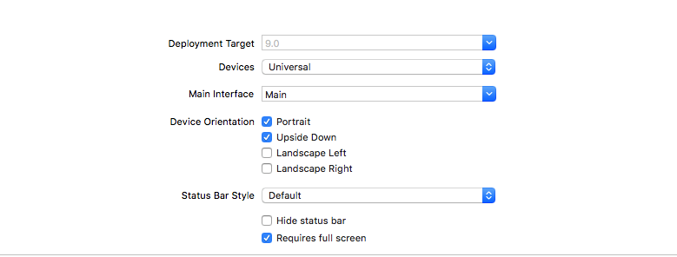

15: Regarding Color Code of App
go to Thememanager.swift file and change the respective color code.
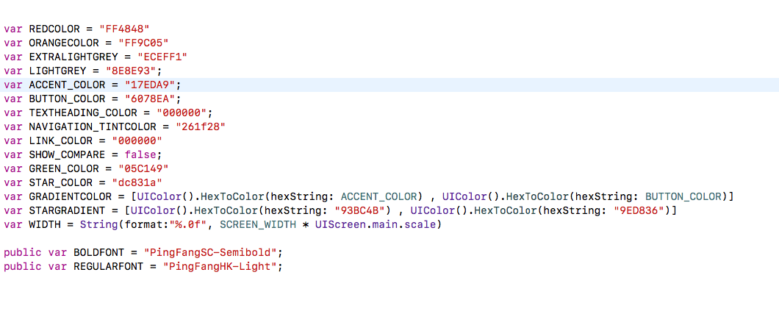
16: To Set the App configuration :
go to AppConfiguration.swift and change the desired credential

